**A LEVEL HISTORY**

**COURSE OUTLINE EDEXCEL 9HI0**

***SOVIET UNION 1917-91***

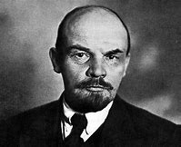[](https://www.bing.com/images/search?q=boris+yeltsin&id=7223F180FDA7DC85B6D4B4683043F820D057CD52&FORM=IARRTH)

*THE GERMAN DEMOCRATIC REPUBLIC 1949-90*

[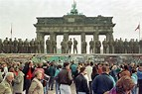](https://www.bing.com/images/search?q=berlin+wall+pictures&id=DF91EA2A1D619F123E5C445977616E65AD72CD98&FORM=IQFRBA)

*ORIGINS OF THE COLD WAR 1945-53*

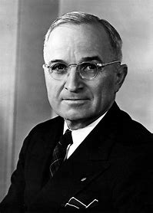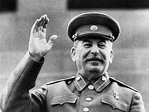

*BRITAIN: LOSING AND GAINING AN EMPIRE 1763-1914*

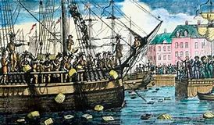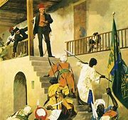

**YEAR 1**

**UNIT 1: THE SOVIET UNION: FROM LENIN TO YELTSIN 1917-91**

This is covered in a thematic approach across the period 1917-85:

* Soviet government
* Industrial and agricultural change
* Control of the people
* Social developments

Additionally, the fall of the USSR c.1985-91 is studied as a historical interpretation.

This unit is examined through a combination of essay and source-based questions.

**UNIT 2: THE GERMAN DEMOCRATIC REPUBLIC 1949-90**

The study of Communist government is developed through a study of the German Democratic Republic, looking at key developments.

* Establishing and consolidating Communist control
* The development of the East German state
* Life in East Germany
* Growing crises and the collapse of Communist rule

This unit is examined through a combination of essay and source-based questions.

**YEAR 2**

**COURSEWORK UNIT: HISTORICAL INTERPRETATIONS OF THE ORICINS OF THE COLD WAR 1945-53**

The study of interpretations of the origins of the Cold War Superpower rivalry through the works of a range of historians. Students research a produce an essay of up to 4000 words.

Was it the Soviet Union or the USA that was responsible? Was it Stalin or Truman? Was it an inevitability in the unique circumstances of the time – the destruction of Germany?

This unit is internally and externally assessed.

**UNIT 3: BRITAIN: LOSING AND GAINING AN EMPIRE 1763-1914**

The study of how Britain lost one empire in North America through the American Revolution and then gained a far wider and diverse empire over the following century. It combines breadth and depth studies over the whole period.

* The changing nature and extent of trade
* The changing nature of the British navy
* The loss of the American colonies
* Canada, Australia, India, the Nile Valley

This unit is examined through a combination of essay and source-based questions.