**A LEVEL POLITICS**

**COURSE OUTLINE: EDEXCEL 9PL0**

***UK POLITICS***



***UK GOVERNMENT***

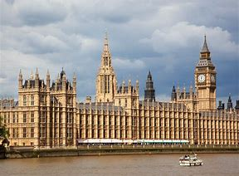

***GLOBAL POLITICS***

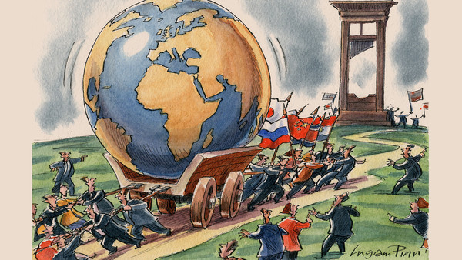

**YEAR 12**

**UNIT 1: UK POLITICS**

This unit covers the core concepts of Politics and how they are relevant to the UK.

* Democracy and Political Participation
* Political Parties
* Elections and the different electoral systems
* Voting Behaviour, including case studies of recent General Elections.
* Ideologies: liberalism, conservatism, socialism

This unit is examined through a combination of essay and source based questions.

**UNIT 2: UK GOVERNMENT**

This unit covers the features of the UK system of government, as well as extending the study of ideologies.

* The UK Constitutions; its sources, nature and recent developments
* Parliament
* The Prime Minister and Cabinet
* The Judiciary
* The study of an alternative ideology from a choice of anarchism, ecologism, feminism,

Multiculturalism or nationalism.

This unit is examined through a combination of essay and source based questions.

**YEAR 13**

**UNIT 3: GLOBAL POLITICS**

This unit covers current international developments and the challenges facing all nations, including global terrorism, poverty, environmental problems, climate change, economic instability, weapons proliferation and failing states.

* The state and globalisation, the features and limitations of national sovereignty.
* Political and economic global governance: the UN, NATO, G7, G20, IMF, World Bank.
* Human rights and environmental challenges.
* Power classifications (hegemony, superpowers, great powers, emerging powers), the impact of types of government; why some nations are more powerful than others?
* Regional blocs including the European Union; why some are more influential than others?
* Comparative theories and their application; realism, liberalism, anarchical society.

The unit will be examined through essay questions, requiring a knowledge of political ideologies as well as global issues and institutions.