**NAME: _____________________________**



**GCSE SUMMER PREPARATION**

**PRESENT TENSE (REGULAR)**

|  |  |  |  |
| --- | --- | --- | --- |
|  | **PRESENTE 🡪 Cut AR/ER/IR off and add ending** | | |
| **-AR** | **-ER** | **-IR** |
| Yo | -o | -o | -o |
| Tú | -as | -es | -es |
| Él/ella | -a | -e | -e |
| Nosotros/as | -amos | -emos | -imos |
| Vosotros/as | -áis | -éis | -ís |
| Ellos/as | -an | -en | -en |

**Conjugate the following verbs:**

**-AR regular**

1. I crush (machacar) = Machaco

2. She speaks (hablar)

3. They dance (bailar)

4. He finds (encontrar)

5. You (tú) ask (preguntar)

6. You (vosotros) shout (gritar)

7. We send (mandar)

8. I look at (mirar)

9. You (tú) sing (cantar)

10. He cooks (cocinar)

11. They cry (llorar)

12. You (vosotros) have dinner (cenar)

**-ER regular**

1. She eats (comer)

2. They drink (beber)

3. We sweep (barrer)

4. You (vosotros) comprehend (comprender)

5. I sell (vender)

6. You (tú) learn (aprender)

**-IR regular**

1. You (tú) live (vivir)

2. We write (escribir)

3. You (vosotros) attend (asistir)

4. He receives (recibir)

5. I squeeze (exprimir)

6. They lie (mentir)

**PRESENT TENSE (IRREGULAR)**

|  |  |  |  |
| --- | --- | --- | --- |
|  | **PRESENTE (IRREGULAR)** | | |
| **IR (to go)** | **HACER (to do)** | **DECIR (to say)** |
| Yo | Voy (I go) | Hago (I do) | Digo (I say) |
| Tú | Vas (you go) | Haces (you do) | Dices (you say) |
| Él/ella | Va (he/she goes) | Hace (he/she does) | Dice (he/she says) |
| Nosotros/as | Vamos (we go) | Hacemos (we do) | Decimos (we say) |
| Vosotros/as | Váis (you all go) | Hacéis (you all do) | Decís (you all say) |
| Ellos/as | Van (they go) | Hacen (they do) | Dicen (they say) |
|  | **ESTAR (to be)** | **SER (to be)** | **TENER (to have)** |
| Yo | Estoy (I am) | Soy (I am) | Tengo |
| Tú | Estás (you are) | Eres | Tienes |
| Él/ella | Está (he/she is) | Es | Tiene |
| Nosotros/as | Estamos (we are) | Somos | Tenemos |
| Vosotros/as | Estáis (you all are) | Sois | Tenéis |
| Ellos/as | Están (they are) | Son | Tienen |

**Translate the following verbs:**

1. I have =
2. You (tú) are (estar) =
3. He goes =
4. We say =
5. You (vosotros) do =
6. They are (ser) =
7. I go =
8. You (vosotras) say =

**Conjugate the verbs in brackets:**

1. Yo ­­__________________ (decir) dos botellas de agua, por favor.
2. Tú __________________ (hacer) deporte todos los días.
3. Mi hermano __________________ (estar) en la ciudad.
4. Mi amiga y yo __________________ (ser) muy habladoras.
5. Vosotros __________________ (tener) un gato negro.
6. Mis padres __________________ (ir) a la playa.

**PRESENT TENSE (STEM CHANGING)**

|  |  |  |  |  |
| --- | --- | --- | --- | --- |
|  | **JUGAR**  (to play) | **PODER**  (to be able to) | **PREFERIR**  (to prefer) | **QUERER**  (to like/want) |
| Yo (I)  Tú (you)  Él/Ella (he/she)  Nosotros (we)  Vosotros (you)  Ellos/as (they) | Juego  Juegas  Juega  Jugamos  Jugáis  Juegan | Puedo  Puedes  Puede  Podemos  Podéis  Pueden | Prefiero  Prefieres  Prefiere  Preferimos  Preferís  Prefieren | Quiero  Quieres  Quiere  Queremos  Queréis  Quieren |

**Complete with the conjugation of JUGAR or PODER:**

1. (Yo) __________________ al fútbol todos los viernes.
2. Vosotros _________________ escribir.
3. Los sábados, Juan y yo ____________________ al baloncesto con un equipo.
4. María _________________ al tenis si hace buen tiempo.
5. Ellos __________________ hablar español.
6. Tú __________________ tocar el violín.

**Complete with the conjugation of PREFERIR or QUERER:**

1. (Yo) __________________ el té al café.
2. Vosotros _________________ sacar buenas notas en inglés.
3. José y yo ____________________ nuestra profesora de matemáticas..
4. Marta _________________ dormir que ir a la escuela.
5. Ellos __________________ ir de vacaciones.
6. Tú __________________ un perro.

**Translate the sentences into Spanish:**

1. I play football with my friends because it is sunny.

**__________________________________________________________________________**

1. We prefer fruits because they are healthy.

**__________________________________________________________________________**

1. They can play the guitar and speak French.

**__________________________________________________________________________**

1. She wants to study history next year.

**__________________________________________________________________________**

**PRESENT TENSE (REFLEXIVE)**

|  |  |
| --- | --- |
|  | **Reflexive pronouns** |
| Yo (I)  Tú (you)  Él/Ella (he/she)  Nosotros (we)  Vosotros (you)  Ellos/as (they) | Me  Te  Se  Nos  Os  Se |

**Complete with the appropriate reflexive pronoun (me, te, se, nos, os, se) then translate into English**

a. el ___se____ despierta = He woke up

b. yo ___ ___ visto =

c. ellos ______ duchan

d. Nosotros _______ levantamos

e. Ella no _______ maquilla

f. Vosotros ______ sentís

g. Nosotros________ peleamos

h. Vosotros _________ laváis

i. yo ________ peino

j. Ellas ________ pintan las unas

k. El no _______ se casa hoy

l. ella _____ levanta

m. yo no ____ siento bien

n. Tú ____ acuestas

o. yo ____ duermo

p. nosotros ____ peinamos el pelo

q. ella ____ enoja.

**Complete with the correct form of the verb in brackets**

a. ___________________ (vestirse) con mi uniforme. (I get dressed with my uniform)

b. ____________________ (despertarse) muy temprano. (We wake up very early)

d. ____________________ (divertirse) leyendo una novela. (They have fun reading a novel)

e. ____________________ (ducharse) siempre antes de acostarme. (I always shower before going to bed)

f. _____________________ (cepillarse) los dientes en la mañana. (We brush my teeth in the morning)

g. _____________________ (sentirse) bien cuando juego al tenis. (You (all) feel good when I play tennis.)

h. _________________ (lavarse) el pelo tres veces a la semana. (She washes my hair three times a week.)

i. Nunca ______________ (afeitarse) antes de ir al colegio. (They never shave before going to school)

j. A menudo ______________ (enfadarse) con su hermano. (You often get angry with her brother)

**IMMEDIATE FUTURE**

**Formation:**

“ir” + a + infinitive

|  |  |  |  |
| --- | --- | --- | --- |
|  | **Ir – to go** | a | **Infinitives** |
| Yo | **Voy** ( I am going) | visitar (visit) |
| Tú | **Vas** (You are going) | ver (to see) |
| Él/ella | **Va** (He/She is going) | comprar (to buy) |
| Nosotros/as | **Vamos** (We are going) | cenar (to have dinner) |
| Vosotros/as | **Vais** ( You all are going) | hacer (to do) |
| Ellos/as | **Van** (They are going) | salir (to go out/leave) |

**Example: Voy a visitar = I’m going to visit**

**Using the infinitives bank, make the following sentences…**

Comprar

Visitar

Vivir

Leer

Ver

Escuchar

Escribir

Ir

Conocer

Hacer turísmo

Cenar

Quedarnos

Probar

1. I am going to go…

_________________________________________________

2. We are going to meet…

_________________________________________________

3. She is going to read…

_________________________________________________

4. They are going to try…

_________________________________________________

5. You all are going to visit…

_________________________________________________

6. We are going to stay…

_________________________________________________

7. He is going to go sightseeing…

__________________________________________________

8. You are going to write

_________________________________________________

9. I am going to buy…

**Consejo: Cross out each infinitive as you use them and use a dictionary to check meanings you are unsure of!**

_________________________________________________

10. They are going to live…

________________________________________________

11. She is going to see…

__________________________________________________

12. We are going to have dinner…

__________________________________________________

13. He is going to listen…

___________________________________________________

**SIMPLE FUTURE**

|  |  |  |  |
| --- | --- | --- | --- |
|  | **FUTURE SIMPLE (I will eat…) 🡪 Infinitive (AR/ER/IR) + ending** | | |
| **-AR** | **-ER** | **-IR** |
| **Yo** | -é | -é | -é |
| **Tú** | -ás | -ás | -ás |
| **Él/ella** | -á | -á | -á |
| **Nosotros/as** | -emos | -emos | -emos |
| **Vosotros/as** | -éis | -éis | -éis |
| **Ellos/as** | -án | -án | -án |

**Fill in the gaps in these sentences, using the appropriate form of the future simple.**

1. Si voy a Venezuela, ______ (ver) el Salto Ángel
2. Te _________ (ayudar) si tengo el tiempo
3. Si no comes, _________ (tener) hambre más tarde
4. Mi madre _________ (comprar) una chaqueta si hace frío
5. Si apruebo mis exámenes _________ (estar) contenta
6. Si tenemos el dinero __________ (ir) de compras
7. Si tienen el tiempo, mis hermanos ________ (venir) al cine
8. ___________ (comer) tapas si vas a Madrid
9. Si no escuchan, no ________ (saber) qué hacer

10. Si termino mis deberes, _________ (poder) ir al centro

**Translate the first four sentences:**

1. __________________________________________________________________________________________________________________________________________________________________
2. ________________________________________________________________________________________________________________________________________________________________________________
3. ________________________________________________________________________________________________________________________________________________________________________________
4. ________________________________________________________________________________________________________________________________________________________________________________

**CONDITIONAL**

|  |  |  |  |
| --- | --- | --- | --- |
|  | **CONDITIONAL (I would eat…) 🡪 Infinitive (AR/ER/IR) + ending** | | |
| **-AR** | **-ER** | **-IR** |
| **Yo** | -ía | -ía | -ía |
| **Tú** | -ías | -ías | -ías |
| **Él/ella** | -ía | -ía | -ía |
| **Nosotros/as** | -íamos | -íamos | -íamos |
| **Vosotros/as** | -íais | -íais | -íais |
| **Ellos/as** | -ían | -ían | -ían |

**Match up the translations from Spanish to English.**

|  |  |
| --- | --- |
| 1. Habré escuchado 2. Habríamos escuchado 3. Habremos cantado 4. Habrían cantado 5. Habrías perdido 6. Habrá perdido 7. Habréis cocinado 8. Habría cocinado | 1. You would have lost 2. I would have cooked 3. I will have listened 4. They would have sung 5. She will have lost 6. We would have listened 7. You will have cooked 8. We will have sung |

**Conjugate the verbs into the conditional tense**

1. _______________ *(beber / yo)* coca cola cada día pero no es muy sana.
2. _______________ *(bailar / nosotras)* el Tango en Argentina.
3. _______________ *(ir / tu)* porque hay sol hoy.
4. _______________ *(comprar / ella)* un vestido con su dinero.
5. _______________ *(hablar / vosotros)* en la clase.
6. Me ____________ *(gustar / yo)* visitar el museo con mi amiga.
7. _______________ *(escuchar / ellos)* la música de JLS todo el tiempo.
8. _______________ *(jugar / tu)* el fútbol en el futuro?

**PRETERITE**

|  |  |  |  |
| --- | --- | --- | --- |
|  | **PRETERITE (past/finished action) 🡪 Cut AR/ER/IR off and add ending** | | |
| **-AR** | **-ER** | **-IR** |
| **Yo** | -é | -í | -í |
| **Tú** | -aste | -iste | -iste |
| **Él/ella** | -ó | -ió | -ió |
| **Nosotros/as** | -amos | -imos | -imos |
| **Vosotros/as** | -astéis | -istéis | -istéis |
| **Ellos/as** | -aron | -ieron | -ieron |

**Write the preterite tense of the verb in brackets.**

1) (tú) _______________ (vender) 6) (nosotros) _______________ (jugar)

2) (ellos, ellas) _______________ (escribir) 7) Pili y Juan _______________ (pasar)

3) Mi hermano _______________ (sacar) 8) Pili _______________ (recibir)

4) (yo) _______________ (tomar) 9) (él, ella) _______________ (aprender)

5) Mis amigos _______________ (comer) 10) (vosotros) _______________ (beber)

**Highlight/circle/underline the correct verb form in each sequence.**

1) (él, ella) bebí bebieron bebió 4) (tú) escuchó escuchaste escuchasteis

2) (yo) nadé nadamos nadaste 5) (ellos, ellas) tomé tomaron tomó

3) (nosotros) escribió escribimos escribí 6) (vosotros) habló hablasteis hablaste

**Shade in the correct verb to match the English meaning as in the example**

|  |  |  |  |
| --- | --- | --- | --- |
| *\* I ate* | como | comí | voy a comer |
| *you (sing.) drink* | bebes | bebiste | vas a beber |
| *s(he) learnt* | aprende | aprendió | va a aprender |
| *we are going to play* | jugamos | jugamos | vamos a jugar |
| *we understood* | comprendemos | comprendimos | vamos a comprender |
| *they learn* | aprenden | aprendieron | van a aprender |
| *they are going to go* | van | fueron | van a ir |
| *I am eating* | como | comí | voy a comer |
| *s(he) didn’t go* | no va | no fue | no va a ir |

**IMPERFECT**

|  |  |  |  |
| --- | --- | --- | --- |
|  | **IMPERFECT (past/ongoing action or something you used to do) 🡪 Cut AR/ER/IR off and add ending** | | |
| **-AR** | **-ER** | **-IR** |
| **Yo** | -aba | -ía | -ía |
| **Tú** | -abas | -ías | -ías |
| **Él/ella** | -aba | -ía | -ía |
| **Nosotros/as** | -ábamos | -íamos | -íamos |
| **Vosotros/as** | -abáis | -íais | -íais |
| **Ellos/as** | -aban | -ían | -ían |

**Conjugate the verbs in the imperfect tense:**

1. Mis amigos ___________ (hablar) de la moda pero la moda no me ____________ (interesar).
2. Cuando mi hermana ____________ (ser) pequeña, ____________ (jugar) al tenis.
3. Nosotros ____________ (leer) mucho; mi hermano ____________ (preferir) los juegos.
4. No ____________ (salir) mucho porque los libros ____________ (ser) tan interesantes.
5. Yo ____________ (comer) mucho chocolate y ____________ (beber) mucha agua.
6. Tú ____________ (tener) mucha suerte. ____________ (encontrar) muchos amigos.
7. Ellos ____________ (practicar) los deportes pero yo ____________ (ver) películas.
8. Vosotros ____________ (decidir) muchas cosas y yo ____________ (sentirse) triste.

**Translate the verbs to Spanish:**

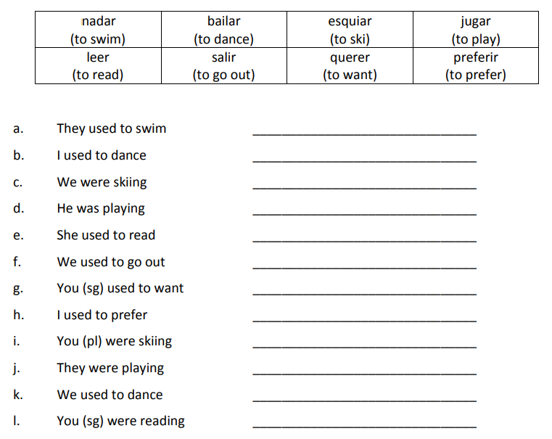

**POSSESSIVE ADJECTIVES**

|  |  |  |
| --- | --- | --- |
| English | Singular | Plural |
| **my** | mi | mis |
| **your (singular)** | tu | tus |
| **his / her** | su | sus |
| **our** | nuestro/a | nuestros/as |
| **your (plural)** | vuestro/a | vuestros/as |
| **their** | su | sus |

Possessive adjectives in English are ‘my’, ‘your’, ‘his’, ‘her’, ‘our’ and ‘their’. They show who an object belongs to. The forms in Spanish are shown opposite.

NOTE I: There is a singular and a plural form for each: *mi* *amigo* is ‘my friend’ but *mis* *amigos* is ‘my friends’

NOTE II: *Nuestro* and *vuestro* have four forms (masculine singular, feminine singular, masculine plural and feminine plural). See below.

|  |  |  |  |
| --- | --- | --- | --- |
| Masc. sing. | Fem. sing. | Masc. plural | Fem. plural |
| ***nuestro***  *piso* | ***nuestra*** *casa* | ***nuestros***  *pisos* | ***nuestras*** *casas* |

NOTE III: *Su(s)* can mean ‘his’, ‘her’ or ‘their’. You can work out from context which is meant. For example, if I say ‘mi hermano hace sus deberes’, you assume that he is doing ‘his’ homework and not hers or theirs.

Translate into Spanish

|  |  |  |
| --- | --- | --- |
| 1). My brothers | 2). My houses | 3). My bed |
| 4). Your (sing.) cat | 5). Your (sing.) computer | 6). Your (sing.) books |
| 7). His tortoise | 8). His homework (pl.) | 9). Her parents |
| 10). Her school | 11). Our subjects | 12). Our sandwiches |
| 13). Our shirt | 14). Our flat | 15). Your (pl.) banana |
| 16). Your (pl.) church | 17). Your (pl.) brothers | 18). Their cinema |
| 19). Their lessons | 20). Their history |  |

1. _______________________________
2. _______________________________
3. _______________________________
4. _______________________________
5. _______________________________
6. _______________________________
7. _______________________________
8. _______________________________
9. _______________________________
10. _______________________________
11. _______________________________
12. _______________________________
13. _______________________________
14. _______________________________
15. _______________________________
16. _______________________________
17. _______________________________
18. _______________________________

**DEFINITE and INDEFINITE ARTICLES**

**Definite Articles**

We use **definite articles** to talk about specific things. It is like saying “the” in English.

*el chico- the boy la chica- the girl los chicos- the boys las chicas- the girls*

They can be **masculine, feminine, singular**, or **plural.**

**definite article noun**

|  |  |  |
| --- | --- | --- |
| singular | el | chico |
| plural | la | chica |
| singular | los | chicos |
| plural | las | chicas |

**Actividad 1:** Fill in the correct *definite article* for each noun below.

1._______ bolígrafo 4. ______ mesas 7. ______ luz

2. ______ bolígrafos 5._______ silla 8. ______ lapices

3. ______ mesa 6. ______ sillas 9. ______ papel

Now let’s try with some complete sentences.

1. _________ chicas son Ana y Luisa.

2. ________ señorita Myers es maestra.

3. ________ estudiantes *tienen* (*have*) ______ carpetas azules.

4. ________ puerta es blanca.

**Indefinite Articles**

We use **indefinite articles** to talk about unspecified things. It is like saying “a,” “an,” or “some” in English.

*un chico- a boy una chica- a girl unos chicos- some boys unas chicas- some girls*

**indefinite article noun**

|  |  |  |
| --- | --- | --- |
| singular | un | chico |
| plural | una | chica |
| singular | unos | chicos |
| plural | unas | chicas |

**Actividad 2:**

1._______ bolígrafo 4. ______ mesas 7. ______ suelo

2. ______ bolígrafos 5._______ silla 8. ______ computadora

3. ______ mesa 6. ______ estudiantes* 9. ______ carpeta

Now let’s try with some complete sentences.

1. ¿Es _______ lápiz amarillo?

2. No, es ______ bolígrafo verde.

3. Son _______ sillas negras.

4. Nosotros somos ________ estudiantes inteligentes.

**TRANSLATION**

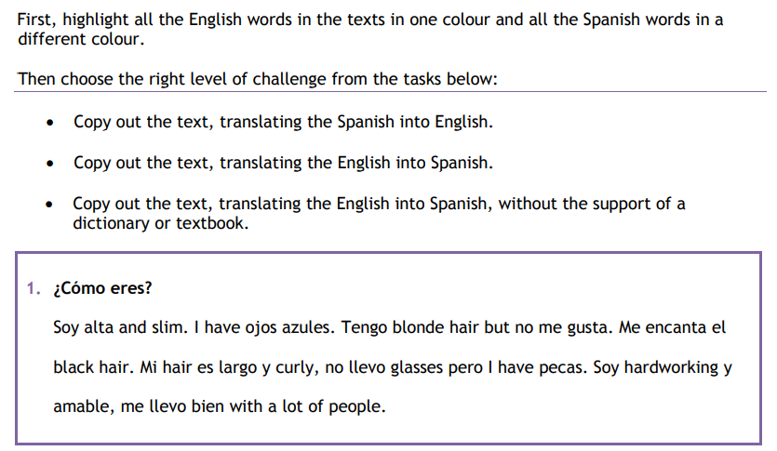

**Into English:**

**________________________________________________________________________________________________________________________________________________________________________________________________________________________________________________________________________________________________________**

**Into Spanish:**

**________________________________________________________________________________________________________________________________________________________________________________________________________________________________________________________________________________________________________**

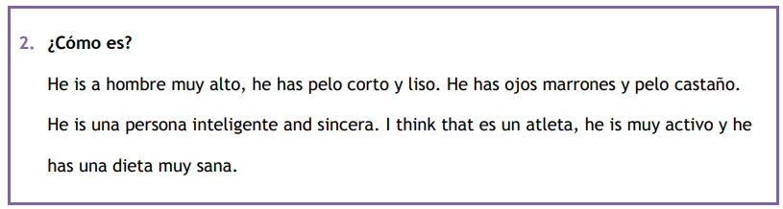

**Into English:**

**________________________________________________________________________________________________________________________________________________________________________________________________________________________________________________________________________________________________________**

**Into Spanish:**

**________________________________________________________________________________________________________________________________________________________________________________________________________________________________________________________________________________________________________**

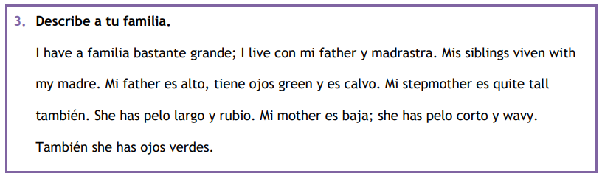

**Into English:**

**________________________________________________________________________________________________________________________________________________________________________________________________________________________________________________________________________________________________________**

**Into Spanish:**

**________________________________________________________________________________________________________________________________________________________________________________________________________________________________________________________________________________________________________**

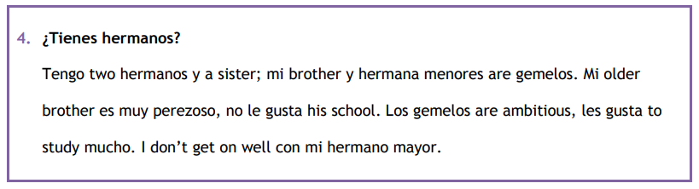

**Into English:**

**________________________________________________________________________________________________________________________________________________________________________________________________________________________________________________________________________________________________________**

**Into Spanish:**

**________________________________________________________________________________________________________________________________________________________________________________________________________________________________________________________________________________________________________**